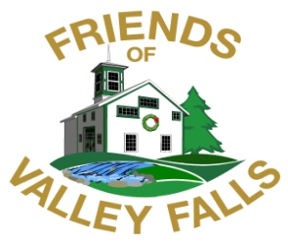

***Preserving History and Nature at Valley Falls***

**PO Box 2008 Vernon CT 06066 860.875.4623**

**Donation Mail-in Form for Non-members**

**Fiscal Year July 1, 2025 to June 30, 2026**

**Name__________________________________________ Zip Code______________**

**Street__________________________________________ Town_________________**

**State____________________ Email______________________________________**

**🞏 *Check here if you’d like to receive our quarterly e-newsletter.***

***E-mail address (print)________________________________***

***(We do not share this information with any organization or business.)***

**🞏 *Check here if you’d like to receive our hard copy newsletter, twice a year.***

**Check Donation Category**

**🞏 Benefactor $500 - $1,000+**

**🞏 Patron $250 - $499**

**🞏 Supporter $100 - $249**

**🞏 Friend $ 5 - $ 99**

**We are a 501(c)(3) nonprofit organization. Your donation is tax-deductible, as allowed by law.**

**🞏 Yes, I would like to be a volunteer for the Friends! Contact** [**annletendr@aol.com**](mailto:annletendr@aol.com)

**“Like us” on facebook at The Friends of Valley Falls, Inc. Vernon CT**