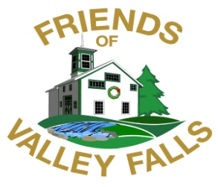

***Preserving History and Nature at Valley Falls***

**PO Box 2008 Vernon CT 06066 860.875.4623**

**Mail-in Membership Form**

**Fiscal Year July 1, 2025 to June 30, 2026**

**Name__________________________________________ Zip Code______________**

**Street__________________________________________ Town_________________**

**State____________________ Email______________________________________**

**🞏 Yes, I want to receive the e-newsletter, emailed quarterly.**

***E-mail address (print) ___________________________________***

***We do not share this information with any organization or business.***

**🞏 Yes, I want to receive the hard copy newsletter, mailed twice a year.**

**Check Membership Category**

**🞏 SENIOR / STUDENT $20**

**🞏 INDIVIDUAL $ 25**

**🞏 FAMILY $ 40**

**🞏 PRESERVATION PARTNER $100**

**🞏 HISTORY HERO $500**

**🞏 LIFETIME DONATION (one-time) $ 1,000**

**Yes! I would like to make an additional contribution to help keep Valley Falls Farm’s historic buildings in good repair! $_________**

***We are a 501(c)(3) non-profit organization. Your contributions are tax-deductible, as allowed by law.***

**Like us on facebook: The Friends of Valley Falls Vernon CT, Inc**